HEALTHIER SHELF-STABLE FOODS

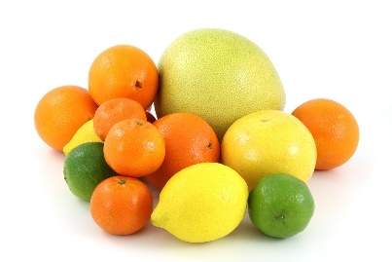
PRODUCE:
Produce with thicker skin will stay fresh longer.
Fruit: Apples, oranges, grapefruit, lemons, limes, clementines
Vegetables: Potatoes, sweet potatoes, winter squash, garlic, onions, carrots, celery, cabbage
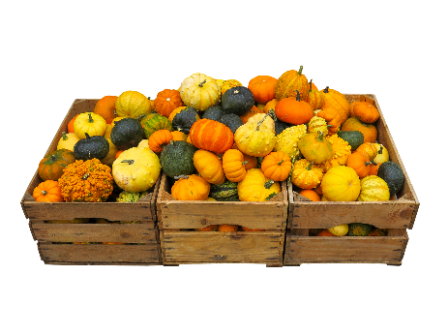
Canned or frozen fruit (in light or no-syrup)
Canned or frozen vegetables
Dried fruit (with less added sugar)

PROTEIN:
Canned or packaged lentils, chickpeas, dried beans and peas
Frozen edamame (soybeans)
Nuts and nut butters
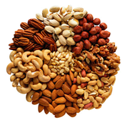
Seeds – flaxseed, sunflower, pumpkin, chia
Canned fish
Canned chicken
Shelf-stable tofu
*DV – Daily Value

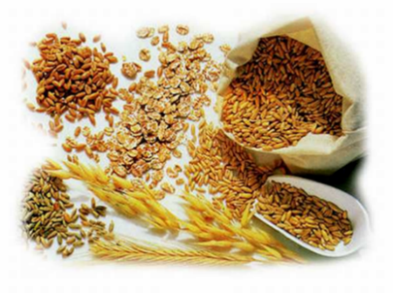
WHOLE GRAINS:
Amaranth Corn tortillas
Barley Brown and wild rice
Buckwheat Farro (wheat kernels)
Popcorn Wheat berries
Quinoa Oats
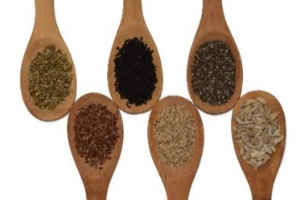
Whole grain crackers

Foods containing calcium
Canned milk
Boxed shelf-stable milk or plant-based dairy alternatives with added calcium
Chia, poppy, and sesame seeds (2 tablespoons ~ 20% DV* for calcium)
Almonds (2 ounces ~ 15% DV for calcium)
Sardines, canned salmon with bones
White beans (1 cup ~ 10% DV for calcium)
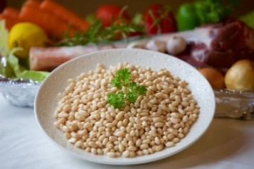
Blackstrap molasses

